* What are three conclusions we can make about Kickstarter campaigns given the provided data?

Based in the Analysis of 4,114 campaigns of Kickstarter, since 2009 to 2017, located in different regions of the world, the Category with most successful Projects is Theater, also we can notice that Music has the highest percentage of success over the total of projects inscribed on this Category. (Chart A)

The Sub-Category who has the most successful campaigns is Plays (Theater Sub-Category). Classical Music, Documentary, hardware, Podcast, Metal Music and nonfiction don’t have the biggest number of campaigns, but all that has been inscribed has been Successful. (Chart B)

The months of the years with the greater rate of success is between May and July, and the greater rate of Failed is on December (also is the only months of the year were the failed campaigns are more than the successful). (Chart C)

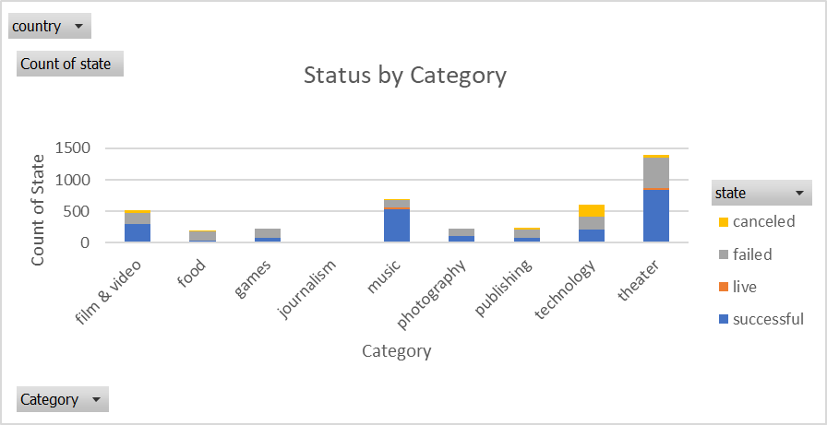

**Chart A**

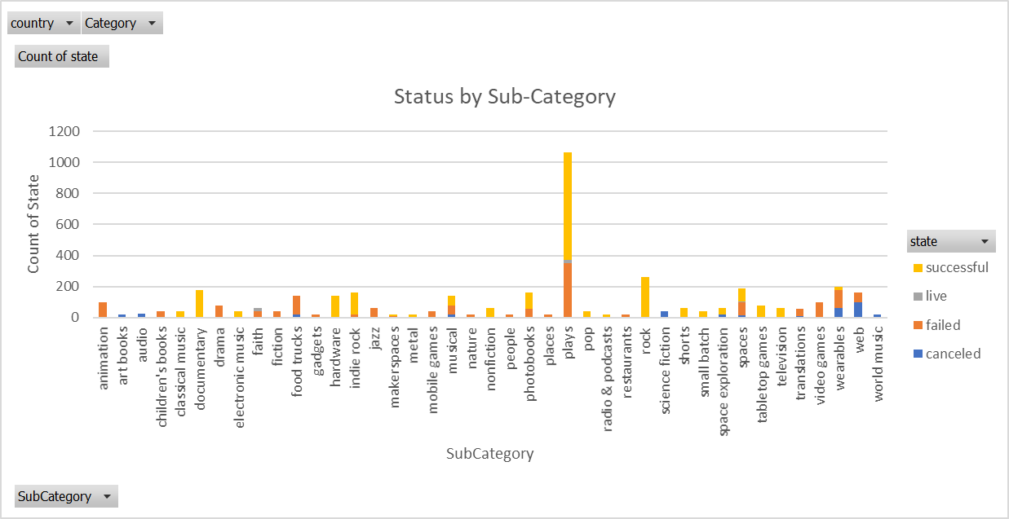

**Chart B**

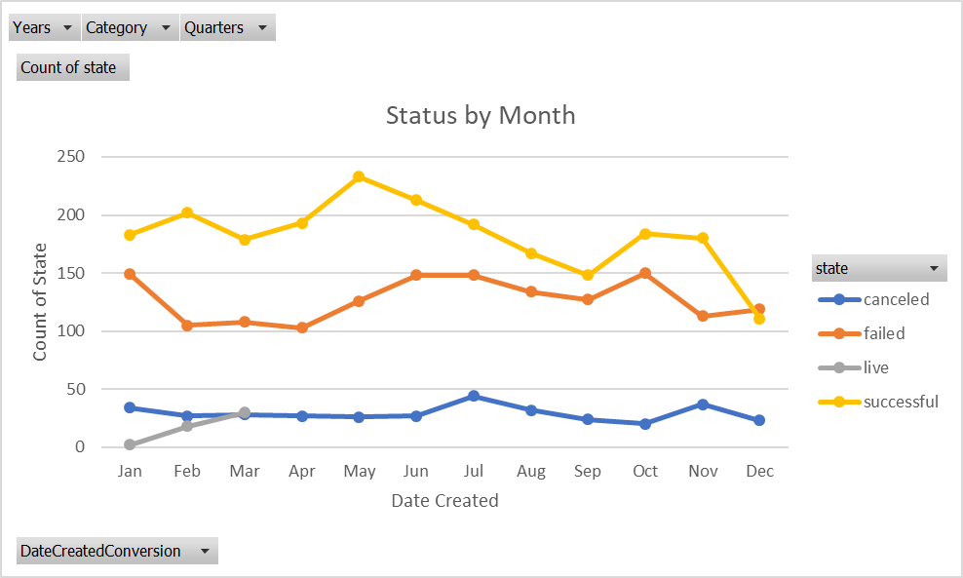

**Chart C**

* What are some of the limitations of this dataset?

The Data may not be representative enough to compare between categories, do the projects differs significantly across them. Theater 1393 projects and food 200.

* What are some other possible tables/graphs that we could create?

We can analyze a linear regression.

We can do a plot of Pledge vs Goal.